**Day 5 Task: Advanced Linux Shell Scripting for DevOps Engineers with User management**

If you noticed that there are total 90 sub directories in the directory '2023' of this repository. What did you think, how did I create 90 directories. Manually one by one or using a script, or a command ?

All 90 directories within seconds using a simple command.

mkdir day{1..90}

**BASH Scripting:**

There are a couple of ways to use for loops depending on the use case and the problem it is trying to automate.

* **Simple For loop**
* **Range-based for loop**
* **Array iteration for loops**
* **C-Styled for loops**
* **Infinite for loop**

## **file and their permissions:**

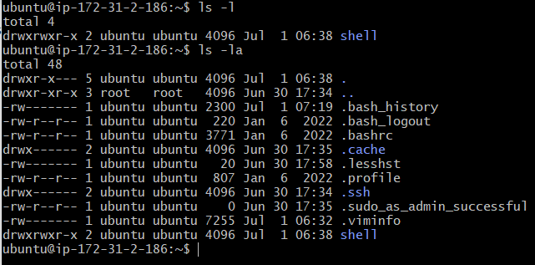

## **Manage file permissions**

To manage file permissions we have a command called chmod which we can use to change the permission of files and directories.

### Method to use chmod command

There are 2 methods to use the command

* Symbolic method
* Numeric method

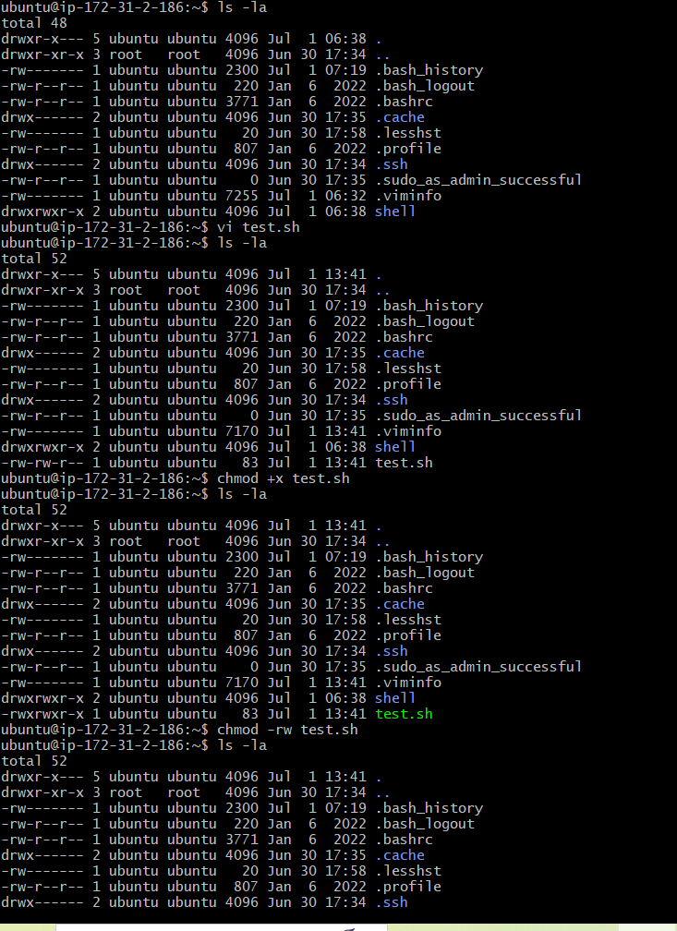

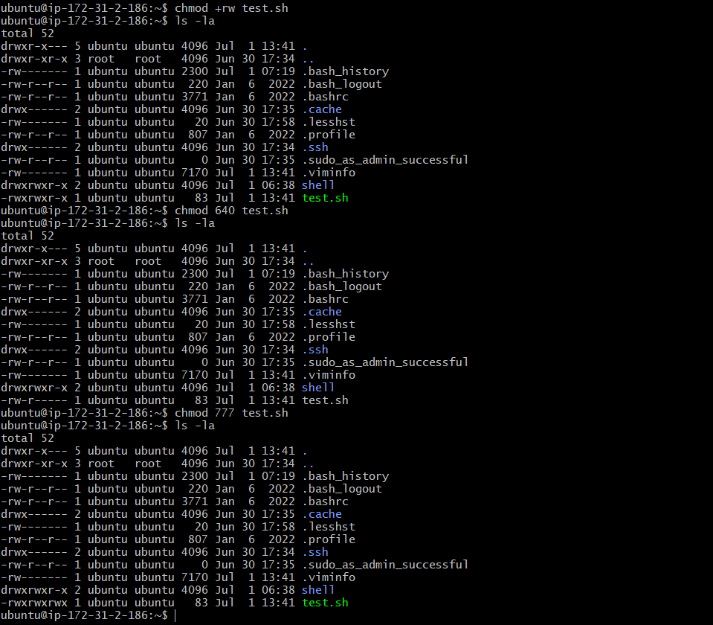

command substitution technique used in a Bash script.

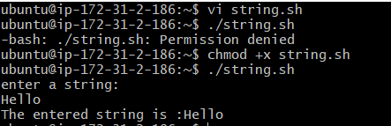

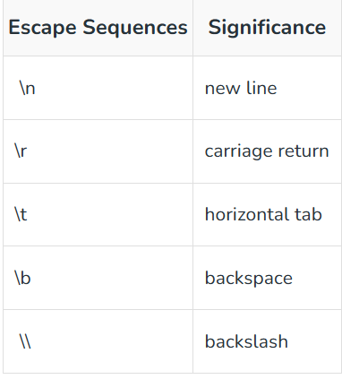

The seq command in Linux is used to print numbers from START to END in steps of INCREMENT.

